**Discrete Element Method model of brain for NPH simulation**

1. Geometry and properties of the initial model

The brain is modeled as a sphere of Discrete Element Method (DEM) particles with 0.1 m radius. The packing of DEM spherical particles is regular hexagonal assembly where DEM particles are positioned in a hexagonal grid, as shown in Fig. 1. Particle properties are shown in Table 1.

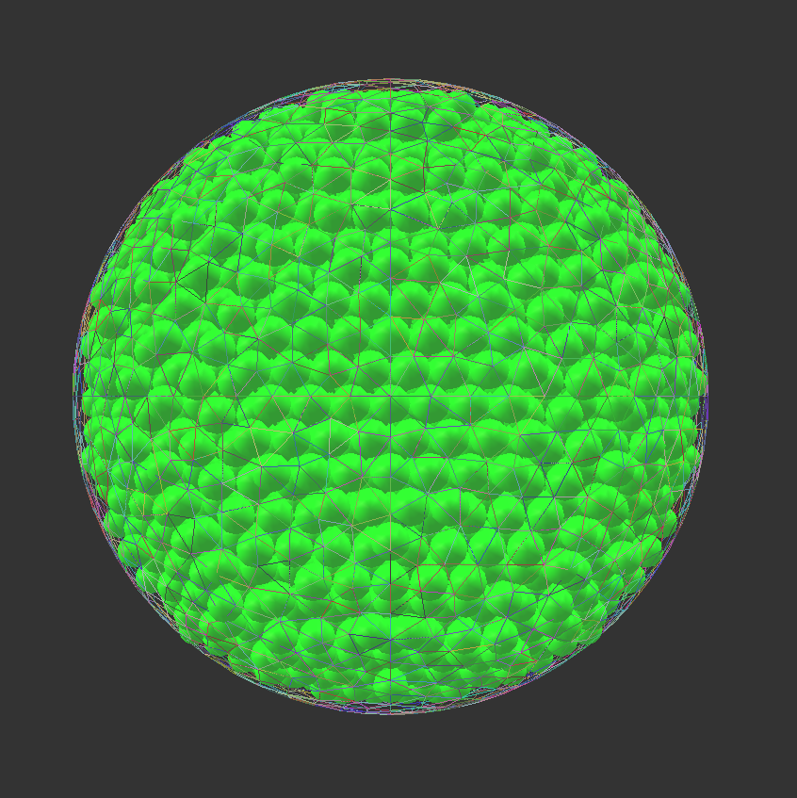  
Figure 1. Assembly of the DEM particles in hexagonal grid forming a sphere

In the literature, there is not much agreement on the material properties of brain tissue. The Young’s modulus can vary between 500 to 10000 Pa. As concerns the Poisson ratio, this varies between 0.35 and 0.48 .⁠ (Li, von Holst, & Kleiven, 2012; Vardakis et al., 2016)⁠.

At the moment, we have have considered an elastic material with contact friction (FrictMat in Yade). The material properties for each of the spheres are listed in Table 2. All the spheres have the same properties. It is also possible to assign different properties to each sphere.

Table 1. Properties of DEM spherical particle and wall (facet)

|  |  |  |
| --- | --- | --- |
| Property | Unit | Value |
| Radius, *R* | m | 0.005 |
| Mass, *m* | kg | 5.24e-4 |
|  |  |  |
|  |  |  |
|  |  |  |

Table 2. Micro properties of the material

|  |  |  |
| --- | --- | --- |
| Property | Unit | Value |
| Poisson’s ratio,  | (-) | 0.35 |
| Friction angle,  | ° | 0.6 |
| Density,  | Kg/m³ | 1000.0 |
| Young modulus, *E* | Pa | 500.0 |
|  |  |  |

1. Contact model and its properties

We use a law for linear compression, and Mohr-Coulomb plasticity surface without cohesion. This law implements the classical linear elastic-plastic law from (Cundall & Strack, 1979)⁠

The compliance of one sphere under point load is defined as , with E the young modulus of the sphere and D its diameter. The compliance of the contact itself will be the sum of compliances from each sphere . The normal stiffness is defined as:

,

and the shear stiffness is defined as:

.

The values are reported in Table 3.

‘The normal force is defined as F . The shear force is and the plasticity condition defines the maximum value of the shear force: , with φ the friction angle.

Table 3. Contact model properties

|  |  |  |
| --- | --- | --- |
| Property | Unit | Value |
| Normal stiffness, | N/m | 2.5 |
| Shear stiffness, | N/m | 0.875 |

Bibliography

Cundall, P. A., & Strack, O. D. L. (1979). A discrete numerical model for granular assemblies. *Géotechnique*, *29*(1), 47–65. https://doi.org/10.1680/geot.1979.29.1.47

Li, X., von Holst, H., & Kleiven, S. (2012). Influences of brain tissue poroelastic constants on intracranial pressure (ICP) during constant-rate infusion. *Computer Methods in Biomechanics and Biomedical Engineering*, (March 2012), 1–14. https://doi.org/10.1080/10255842.2012.670853

Vardakis, J. C., Chou, D., Tully, B. J., Hung, C. C., Lee, T. H., Tsui, P. H., & Ventikos, Y. (2016). Investigating cerebral oedema using poroelasticity. *Medical Engineering and Physics*, *38*(1), 48–57. https://doi.org/10.1016/j.medengphy.2015.09.006